**PROGRAM FOR CALCULATOR IN NODEJS**

let http = require('http');

let fs = require ('fs');

let handleRequest = (request, response) => {

response.writeHead (200, (

'Content-Type': 'text/html'

});

fs.readFile('./index1.xml', null, function (error, data) {

if (error) {

response.writeHead (404);

respone.write('file not found');

} else {

response.write(data);

}

response.end();

});

};

const argvs = process.argv

const argv = argvs.slice(2)

const operation = argv[0]

const operator1 = parseInt(argv[1])

const operator2 = parseInt(argv[2])

if (operation === 'add') {

console.log(operation + ' is '+ (operator1 + operator2));

}

if (operation === 'subtract') {

console.log(operation + ' is '+ (operator1 - operator2));

}

if (operation === 'multiply') {

console.log(operation + ' is '+ (operator1 * operator2));

}

if (operation === 'divide') {

console.log(operation + ' is '+ (operator1 / operator2));

}

http.createServer (handleRequest).listen(7000);

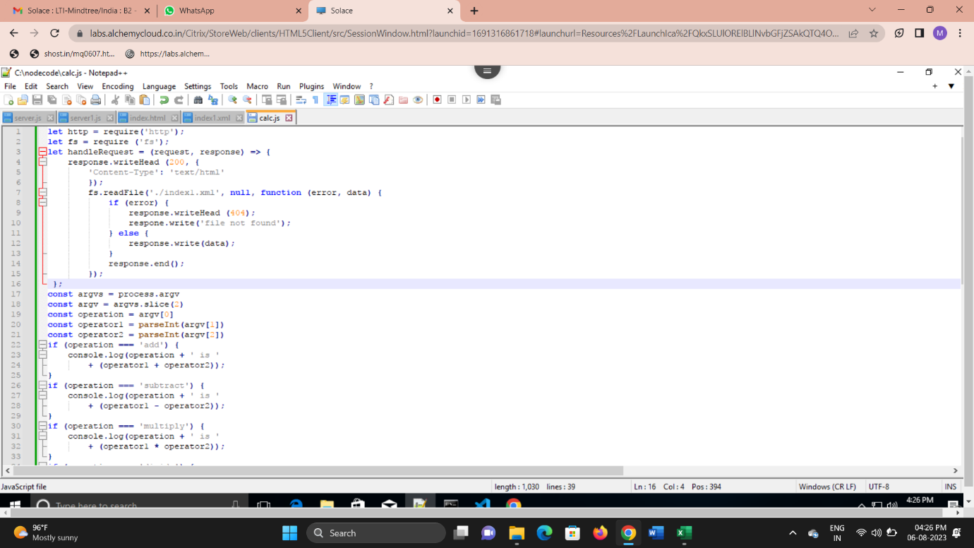

**XML PROGRAM**

<xml>

<title>Dummy Calculator</title>

<body>program successful</body>

</xml>

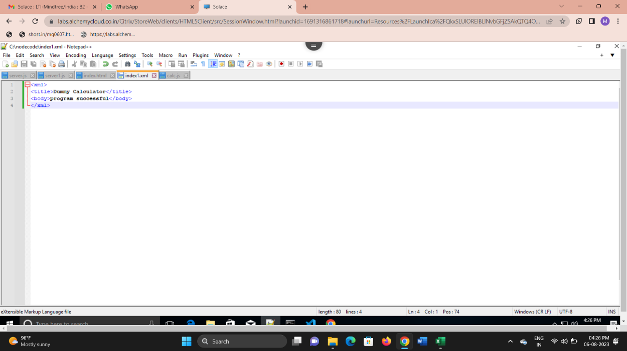

**TERMINAL**

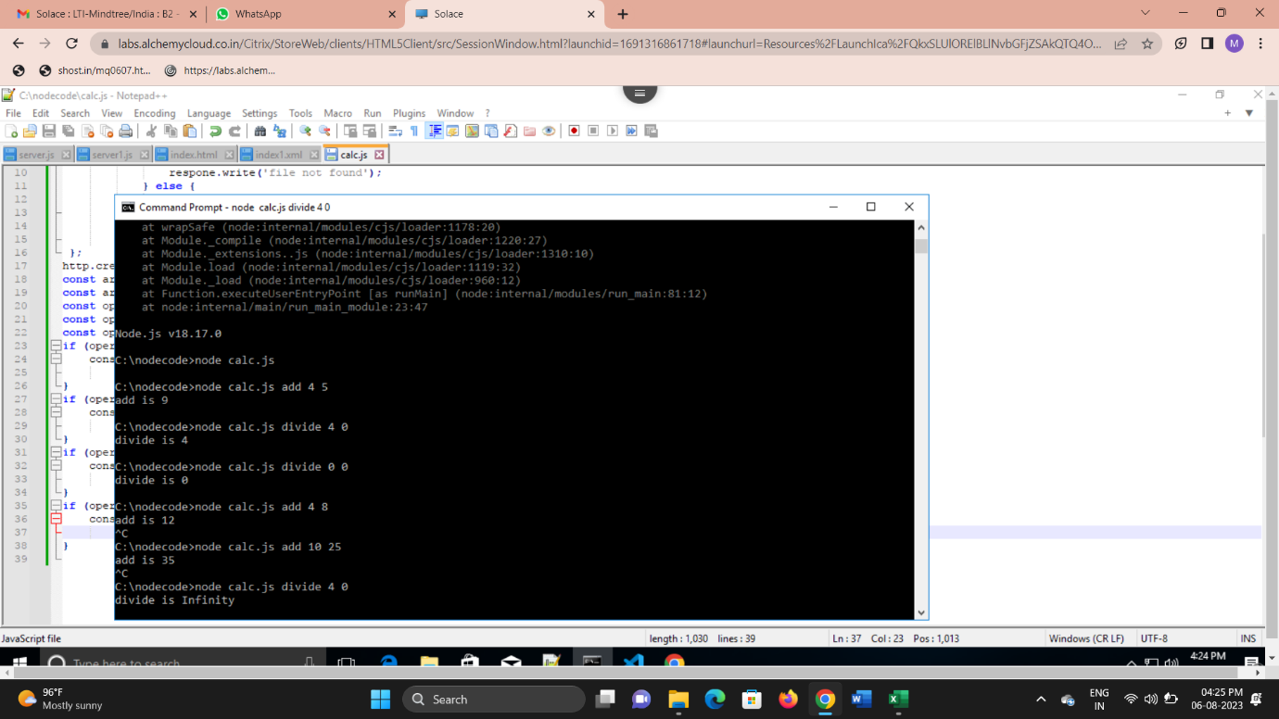

**BROWSER**

